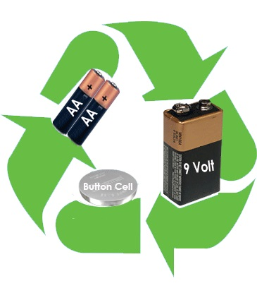

You can make your community and the planet safer by recycling your used batteries. Recycling batteries is easy and provides many benefits, including:
- Preventing potentially hazardous materials from entering the waste stream
- Protecting against fires that can be caused by trashed batteries
- Conserving natural resources

Bring your batteries to the library and the Lion’s Club will pick them up and recycle them for you. We take small household batteries such as AA, 9-Volt and hearing aid batteries, but cannot process large power tool or car batteries.

Thank you for helping to make the planet a little greener!

